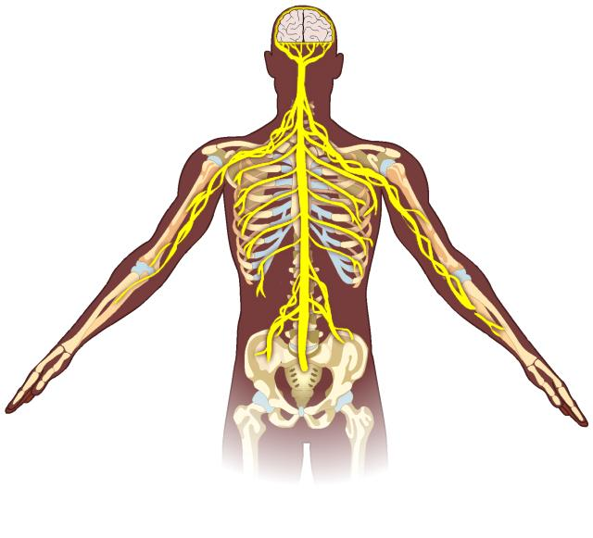
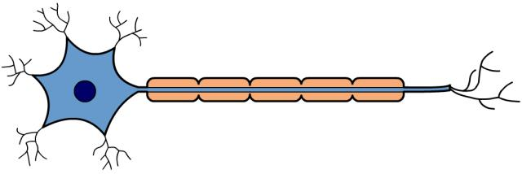
The Nervous System Worksheet

- Answer the following questions about the CNS.

a) In humans and other vertebrates, the CNS is made up of the spinal cord and brain. What does CNS stand for?

………………………………………………………………………………………….……………
b) The peripheral nervous system connects the CNS to the rest of the body via neurones that run to and from the CNS. Name this neurone and label its parts using the words in the box below.
………………...........

………………...........

………………...........
……………….........

axon cell body dendrites myelin sheath

c) Why are the axons of neurones surrounded by a myelin sheath?

………………………………………………………………………………………….……………
………………………………………………………………………………………….……………

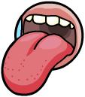
- Answer the following questions about sensory responses.

- Receptors enable us to detect certain types of stimuli. Receptors are found in sense organs. Name two sense organs and the types of receptors found in them.

………………………………………………………………………………………….……………

b) Effectors are the organs that carry out the responses. Give two examples of effectors in the human body.

………………………………………………………………………………………….……………

c) Explain what happens in terms of stimulus and response when a lion spies a gazelle in a bush 10 metres in front of him. Use the following terms in your answer: stimulus, receptor, response, effector, electrical impulse, brain, motor neurone, eye, muscle.

………………………………………………………………………………………….……………
………………………………………………………………………………………….……………
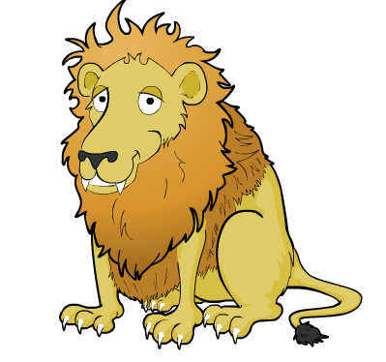
………………………………………………………………………………………….……………
………………………………………………………………………………………….……………
………………………………………………………………………………………….……………
………………………………………………………………………………………….……………
………………………………………………………………………………………….……………

- Match the nervous system key words to their definitions.

Synapse |  | An automatic response to a stimulus that is not processed by the brain.
Receptor |  | Connects a motor and a sensory neurone in the central nervous system and is involved in a reflex arc.
Sensory neurone |  | Carries the nerve impulse from the central nervous system to an effector.
Motor neurone |  | Electrical message that passes along a neurone.
Reflex |  | Changes in the environment that can be detected by sensory organs.
Relay neurone |  | A connection between two neurones.
Stimuli |  | A bundle of neurones.
Effectors |  | The brain and the spinal cord.
Central nervous system |  | Carry out the response and are either muscles or glands.
Nerve |  | This carries the nerve impulse from the receptors in sensory organs to the central nervous system.
Nerve impulse |  | Specialised cells that detect stimuli.

